Digital Media Project - FAQ’s

1. Why do I need to learn this way?
Technology has changed the way we socialise, learn and communicate in the digital age. It is a requirement for new professionals in all the disciplines to be able to communicate in the digital space. To produce engaging and effective digital media artefacts, we need to understand the content to present but also the digital media principles and tools to create digital artefacts for online distribution. The idea behind this assessment is for you to learn the subject content, further develop your digital media skills and work collaboratively in an authentic task. You will have the opportunity to be creative and learn digital media.

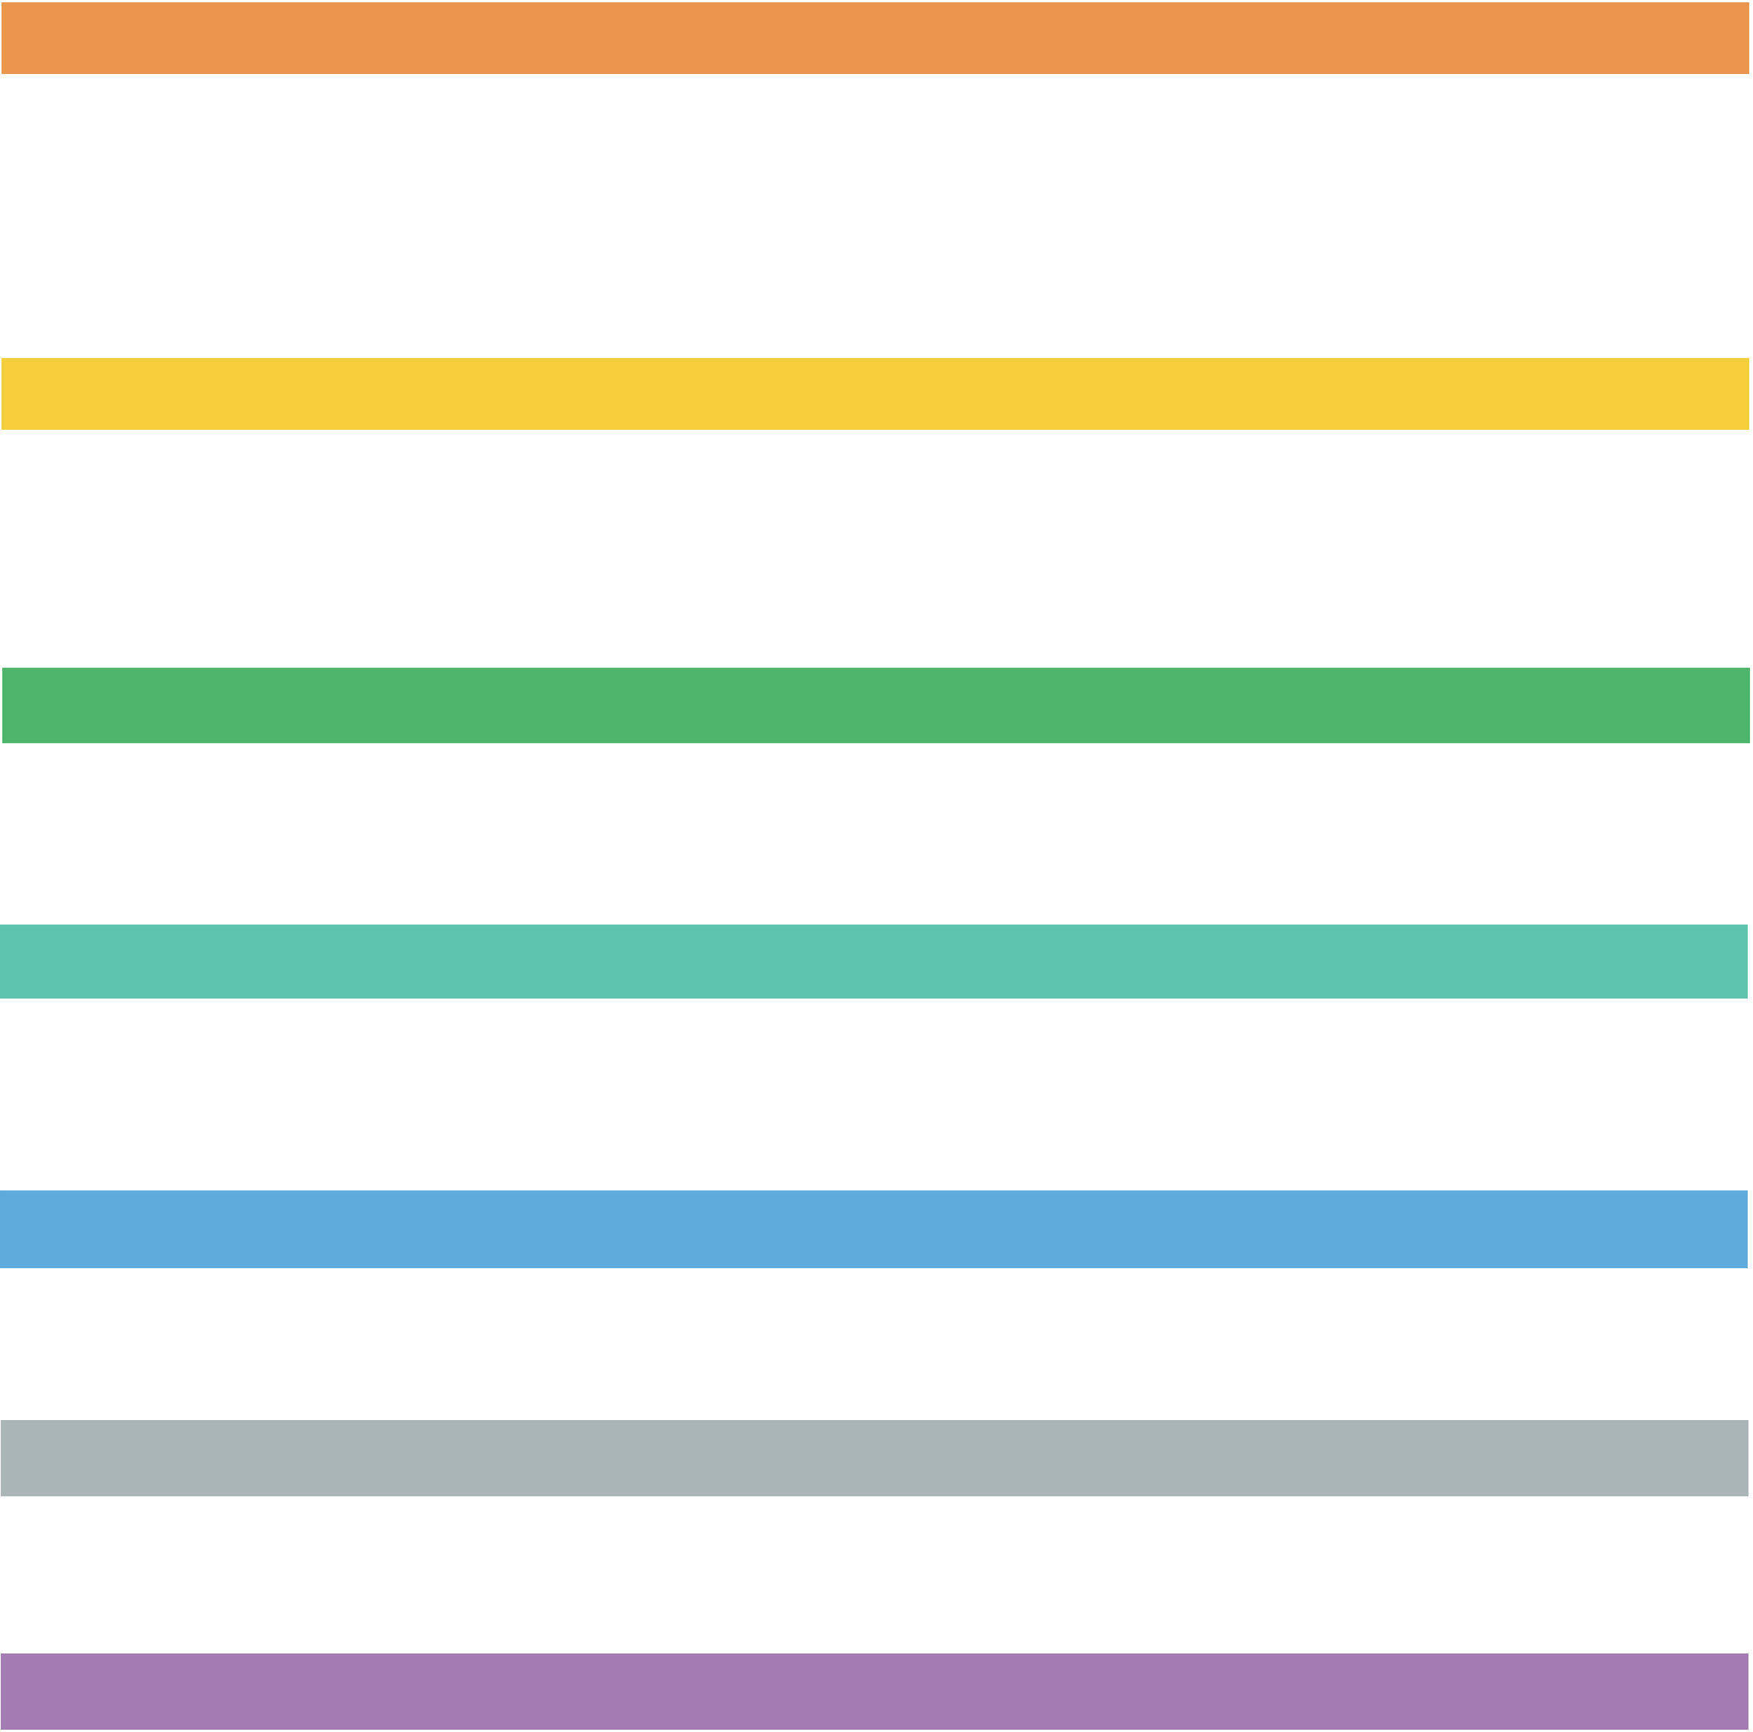
How do I create a digital media project?
With the digital media interactive material on this website, we will be covering the basic principles to create digital media such as layout design, colour theory, typography, use of images and video principles. You will be introduced to storyboarding to brainstorm your ideas. Bear in mind; digital media skills are not acquired quickly. We are expecting you to apply these principles gradually in further assignments for other subjects.

Where do I upload my digital media project?
The platform of choice will depend on your institution, YouTube, Vimeo or your Learning Management System. Your educator should provide instructions on how to upload content. You will be given the opportunity to showcase your group work to the world and help other people to learn with your digital presentation.

How is our digital media project to be marked?
Your lecturer/teacher will provide a marking rubric for you to understand the criteria and ask questions if required.

How do we ensure everyone contributes?

Your lecturer will put in place a mechanism to ensure you will have the opportunity to peer-review the contribution of your team to make the assignment fair. You will receive further instructions later on.

How am I progressing with the digital media project?
You will receive feedback from your lecturer on your storyboard and digital tools to consider for your project. Additionally, resources are provided on the website.

How was the learning experience?
You will be given the opportunity to reflect on how was the experience? What you achieved with the project? What have you learnt?

What could be improved?
You will be given the opportunity to tell your lecturer what did you enjoy and what it can be improved it. With your feedback, they will improve the assignment for the next session. Hope you enjoy it and have fun!

